k;ji m

**E-commerce Sales Analytics SQl Queries**

kpi’s

1.List top-selling products.

(select top 10 orders.product_id,products.product_name ,sum(quantity) as sum_orders

* from orders
* left join products
* on orders.product_id = products.product_id
* group by orders.product_id,products.product_name
* order by sum_orders desc )

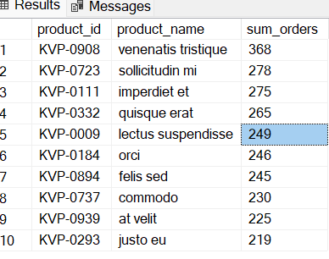

2. Find the total revenue generated.

SELECT SUM(T_price) as Total_revenu from (select

o.product_id,product_name,product_price, quantity ,(quantity*product_price) as T_price

from

orders o

join products p

on o.product_id=p.product_id) as sub_query

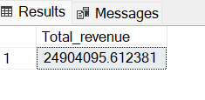

3. Identify the most valuable customers.

select top 10 orders.customer_id,concat(first_name,' ',last_name)as Name, round(sum(product_price*quantity),2) as price

from orders

left Join products

on products.product_id = orders.product_id

left join customers

on orders.customer_id=customers.customer_id

group by orders.customer_id,concat(first_name, ' ',last_name)

order by price desc;

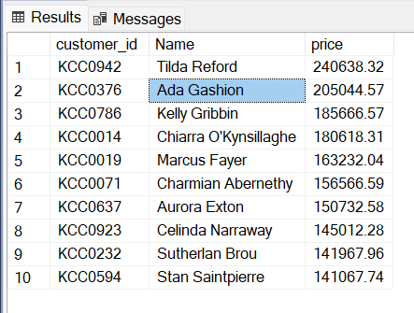

4) Calculate the average order value.

select sum(o.quantity*p.product_price) / count(distinct(o.order_id)) as Average_order_value

from orders o

join products p on o.product_id=p.product_id

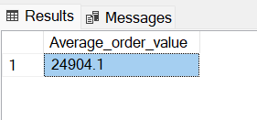

5)Break down the total revenue by month.

select

month(order_date )as monthz,

DATENAME(MONTH,order_date) as month ,

count(DATENAME(MONTH,order_date)) as sales,

round(sum(p.product_price *quantity),2) as revenue

from orders o

left join

products p on o.product_id = p. product_id

group by month(order_date ),DATENAME(MONTH,order_date)

order by monthz;

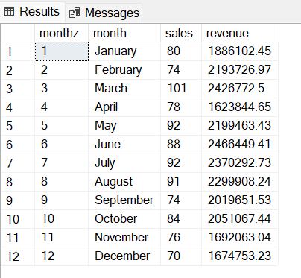

7) calculate monthly or quarterly revenue

SELECT

CASE

WHEN MONTH(o.order_date) IN (1,2,3) THEN '1st quarter'

WHEN MONTH(o.order_date) IN (4,5,6) THEN '2nd quarter'

WHEN MONTH(o.order_date) IN (7,8,9) THEN '3rd quarter'

WHEN MONTH(o.order_date) IN (10,11,12) THEN '4th quarter'

END AS quarters,

round(SUM(o.quantity * p.product_price),2) AS revenue

FROM orders o

LEFT JOIN products p ON o.product_id = p.product_id

GROUP BY

CASE

WHEN MONTH(o.order_date) IN (1,2,3) THEN '1st quarter'

WHEN MONTH(o.order_date) IN (4,5,6) THEN '2nd quarter'

WHEN MONTH(o.order_date) IN (7,8,9) THEN '3rd quarter'

WHEN MONTH(o.order_date) IN (10,11,12) THEN '4th quarter'

END

order by revenue desc ;

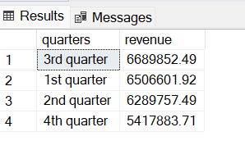

8) Identify the top product categories by total revenue.

select product_category,round(sum(product_price*quantity),2) as Revenue

from orders

left join products

on orders.product_id=products.product_id

group by product_category

order by Revenue desc;

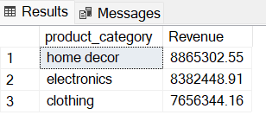

9)Count the number of repeat customers.

select count(count_repeated_customer) as repeated_customer from

(select count(customer_id) as count_repeated_customer

from orders

group by customer_id) as customer_count

where count_repeated_customer >1

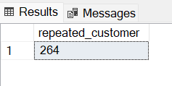

10) Calculate the customer churn rate.

select count(distinct customer_id) as total_customer from customers

select count(distinct customer_id) as order_customer from orders

SELECT

Cast (count (c.customer_id) - count (DISTINCT o.customer_id) as float )

/ COUNT(c.customer_id)* 100 AS churn_rate

from Customers c

JOIN Orders o

on c.customer_id = o.customer_id;

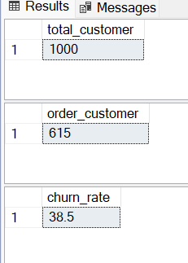

11) Find the most popular products in a specific category

select count(orders.product_id) as count,orders.product_id,product_name

from orders

left join products

on products.product_id=orders.product_id

where products.product_category = 'electronics'

group by orders.product_id,product_name

order by count desc;

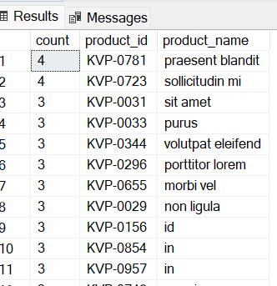

12)Identify products that haven't been sold in the last three months.

WITH Last3_MONTH AS (SELECT

p.product_id,

p.product_name,

p.product_category,

order_date,

DATEDIFF(MONTH, o.order_date, (SELECT MAX(order_date) FROM orders)) AS Month_difference

FROM

products p

join

orders o ON p.product_id = o.product_id

AND DATEDIFF(MONTH, o.order_date, (SELECT MAX(order_date) FROM orders)) <= 3)

select

product_id,

product_name,

product_category

from products

where product_id not in (SELECT product_id FROM Last3_MONTH)

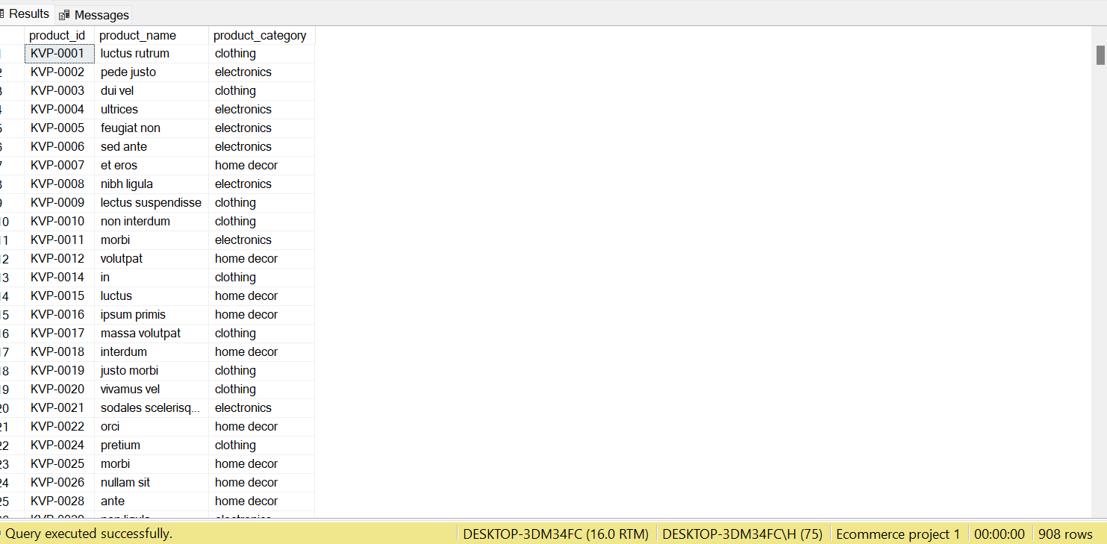

13)Calculate the average transaction value for each customer

select

customer_id,sum(quantity * price) as transac,

count(customer_id) as counts ,

round(sum(quantity * price)/count(customer_id),2) as avg

from [transaction]

group by customer_id

order by transac desc;

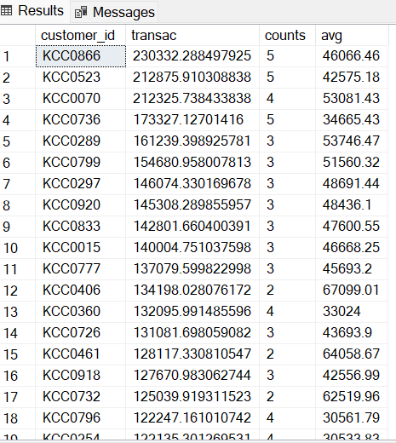

14)Determine the percentage of total revenue contributed by the top 10 customers.

SELECT TOP 10

o.customer_id,

CONCAT(c.first_name, ' ', c.last_name) AS Name,

ROUND(SUM(o.quantity * p.product_price), 2) AS customer_revenue,

ROUND((SUM(o.quantity * p.product_price) /

(SELECT SUM(o.quantity * p.product_price) FROM orders o

LEFT JOIN products p ON o.product_id = p.product_id)) * 100, 2) AS revenue_percentage

FROM orders o

LEFT JOIN customers c ON o.customer_id = c.customer_id

LEFT JOIN products p ON p.product_id = o.product_id

GROUP BY o.customer_id, c.first_name, c.last_name

ORDER BY revenue_percentage DESC;

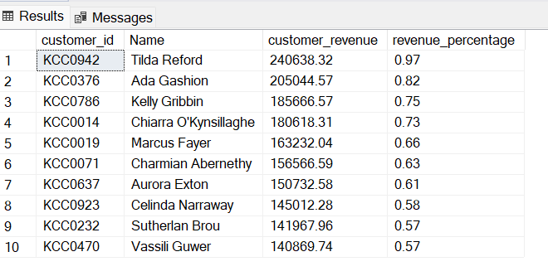

15) Identify the days with the highest number of sales.

YEAR(order_date) AS yearz,

DATENAME(month,order_date) as monthzname,

day(order_date) as dayz,

round(sum(p.product_price *quantity),2) as revenue

from orders o

left join

products p on o.product_id = p. product_id

group by YEAR ( order_date),

DATENAME(month,order_date),

day (order_date)

order by revenue desc;

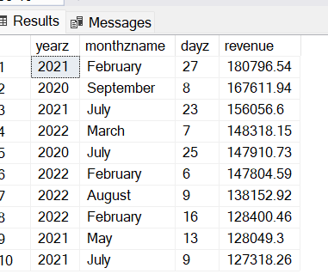

16) Calculate the average number of products included in each order.

SELECT

ROUND(SUM(quantity) / COUNT(DISTINCT order_id), 2) AS avg_products_per_order

FROM

orders;

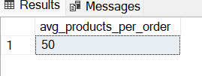

17) Customers segment

select orders.customer_id, concat(first_name,' ',last_name),count(orders.customer_id) as counts,

case

when count(orders.customer_id) = 1 then 'New Customer'

when count(orders.customer_id) <= 4 then 'Repeat Customer'

when count(orders.customer_id) > 4 then 'High-Value Customer'

END AS customer_category

from orders

left join customers

on customers.customer_id=orders.customer_id

group by orders.customer_id, concat(first_name,' ',last_name)

order by counts desc

;

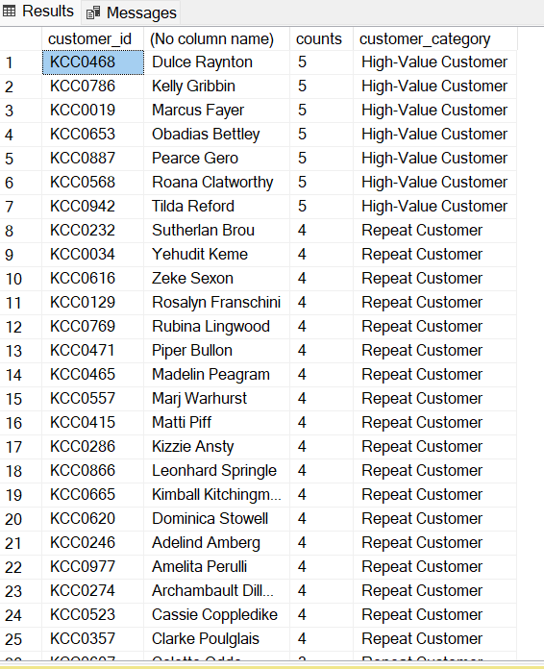

18) Growth rate(YOY)

with cte as

(SELECT

YEAR(o.order_date) AS year,

round(SUM(p.product_price * o.quantity),2) AS revenue,

LAG(SUM(p.product_price * o.quantity)) OVER (ORDER BY YEAR(o.order_date)) AS previous_year

FROM orders o

JOIN products p

ON o.product_id = p.product_id

GROUP BY YEAR(o.order_date)

)

select year,revenue,

ROUND( isnull(((revenue - previous_year)/previous_year)*100,0),2) as growth_rate

from cte

